**Concepts of Operating System**

# Assignment. 1

Problem 1: Read the instructions carefully and answer accordingly. If there is

any need to insert some data then do that as well.

1. Navigate and List:

a. Start by navigating to your home directory and list its contents. Then, move into a

directory named "LinuxAssignment" if it exists; otherwise, create it.

-->>

ls

Directory Created Using :- mkdir LinuxAssignment

To navigate the directory then :-

cd LinuxAssignment

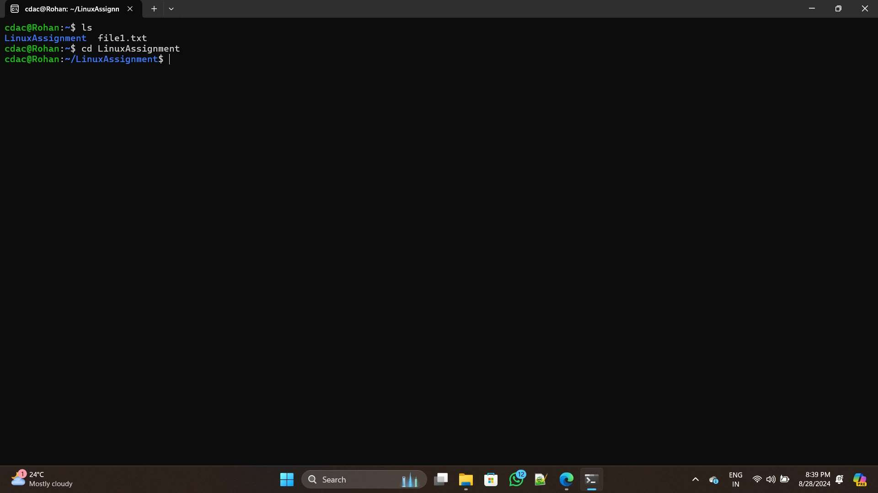

1. File Management:

a. Inside the "LinuxAssignment" directory, create a new file named "file1.txt".

Display its contents.

-->>

1.) Navigate the directory by using :-

cd ~/LinuxAssignment

2.) Create a new file by using :- touch file1.txt

3.) Now, create & add content at the same time by using :- cat > file1.txt

After running cat command, type the content & press Ctrl+D to save & exit.

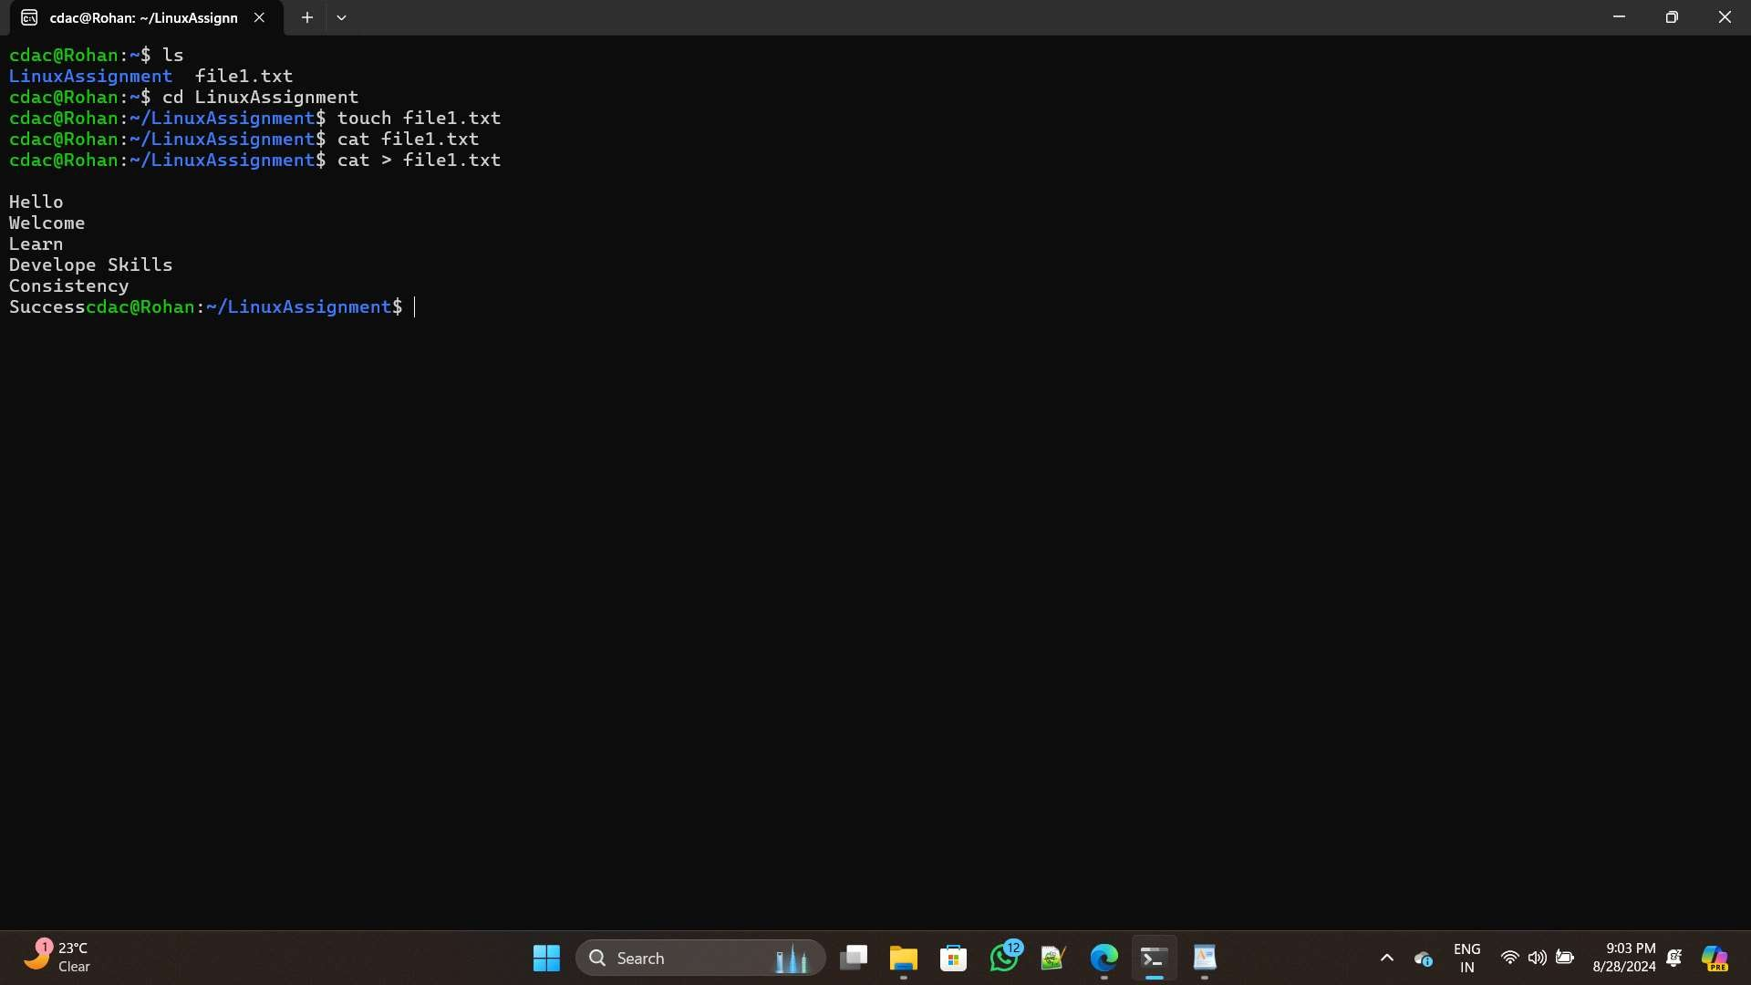

1. Directory Management:

a. Create a new directory named "docs" inside the "LinuxAssignment"

directory.

-->>

To create new directory named docs use command :- mkdir docs

And to verify the directory created or not then use this command :- ls

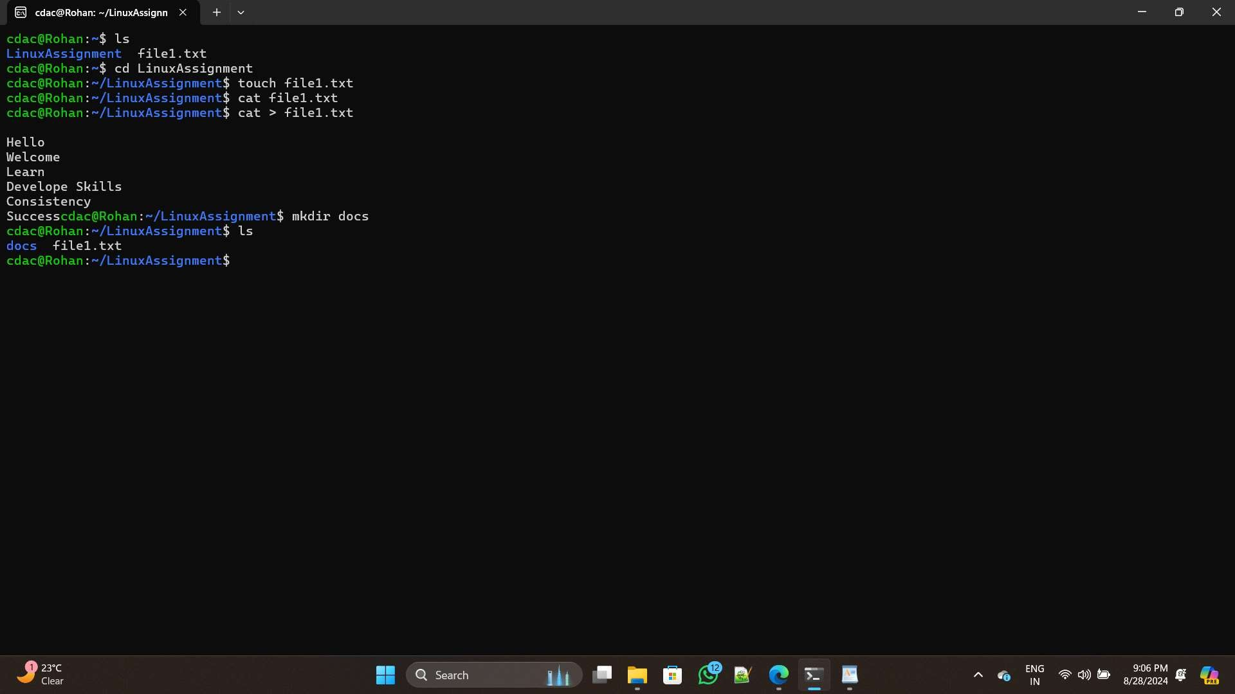

1. Copy and Move Files:

a. Copy the "file1.txt" file into the "docs" directory and rename it to "file2.txt".

-->>

To copy " file1.txt " to the "docs" directory & rename it to " file2.txt ":- cp file1.txt docs/file2.txt

And to confirm the rename :- ls docs

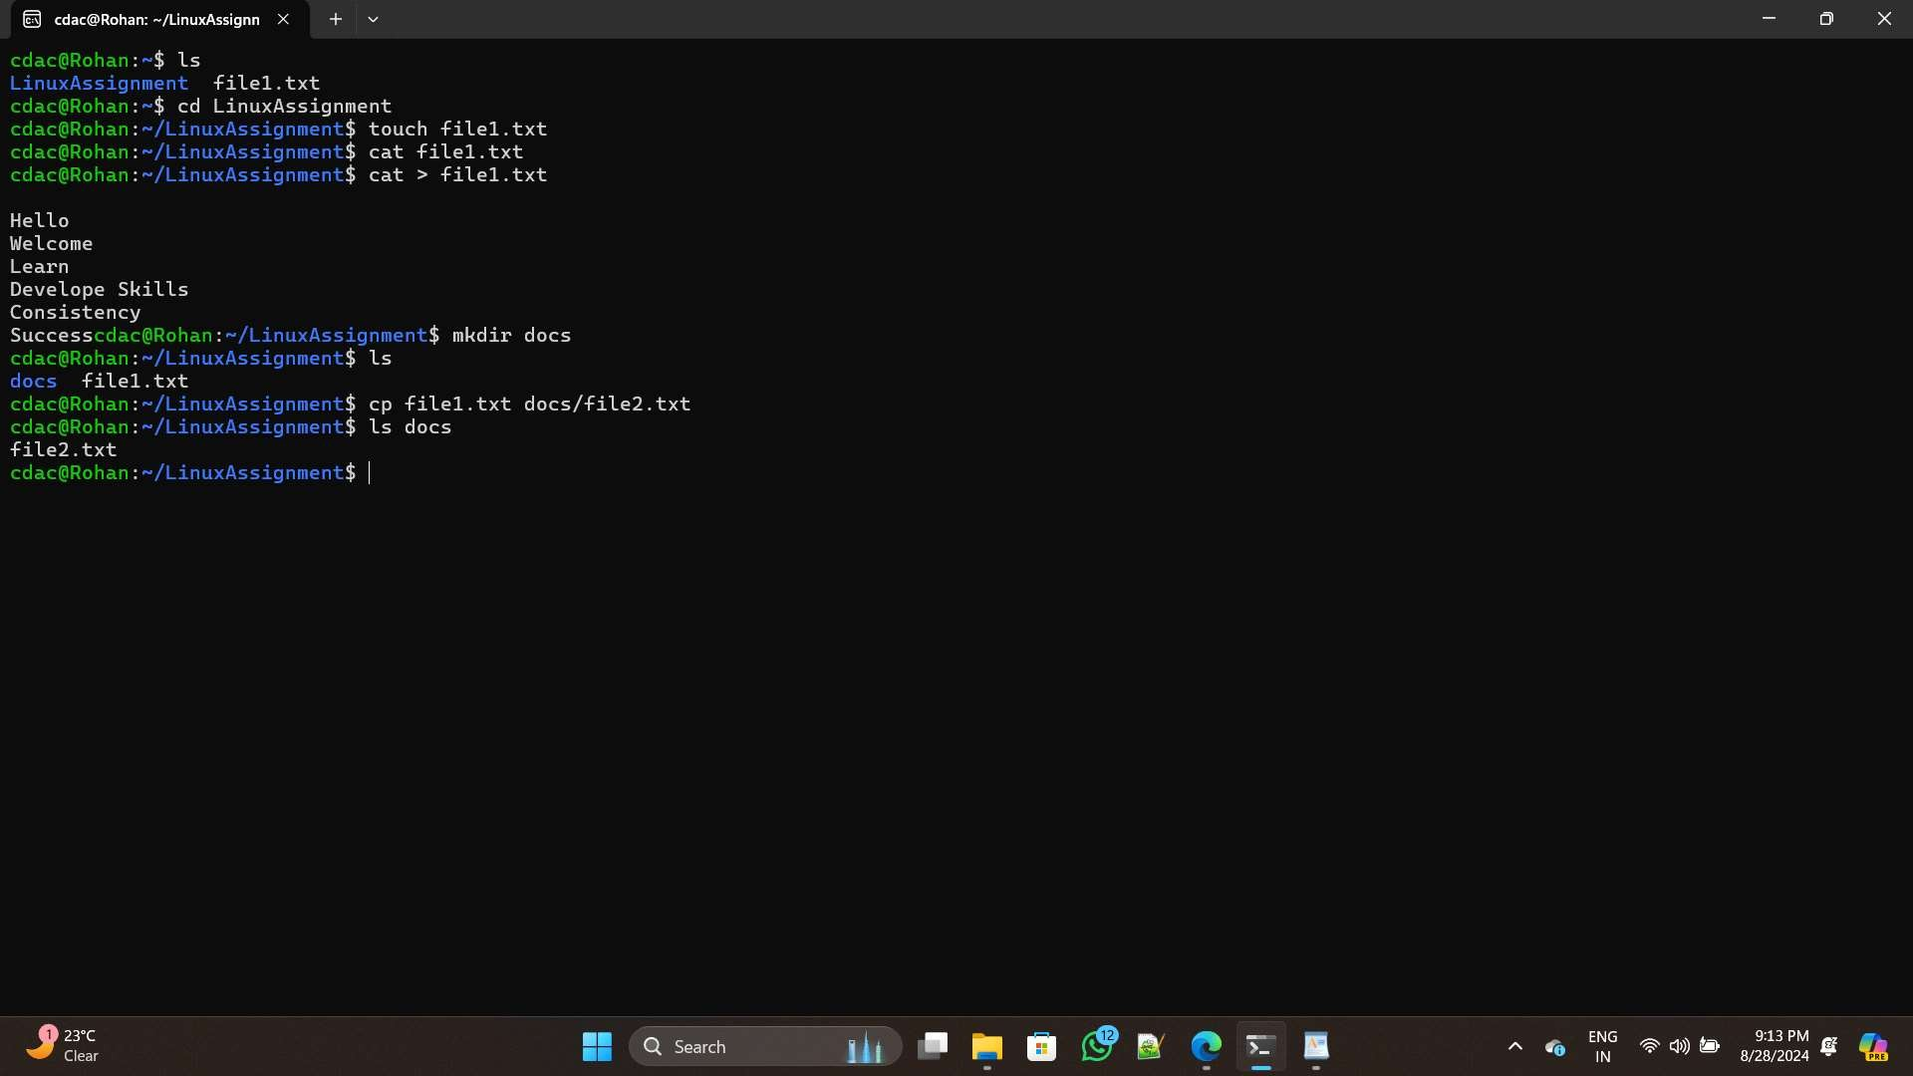

1. Permissions and Ownership:

a. Change the permissions of "file2.txt" to allow read, write, and execute permissions for

the owner and only read permissions for others. Then, change the owner of

"file2.txt" to

the current user.

-->>

1.) Change the permissions of "file2.txt":

If we want to set the permissions to: Read, write, and execute for the owner & Read-only for others.

In numerical mode, this translates to 744 (owner: 7 = read, write, execute; others: 4 = read). Use this command to set these permissions:

chmod 744 docs/file2.txt Determine the current username:

whoami

To change the owner to the current user, use the chown command:- sudo chown cdac docs/file2.txt

Now, verify the changes with :- ls -l docs/file2.txt

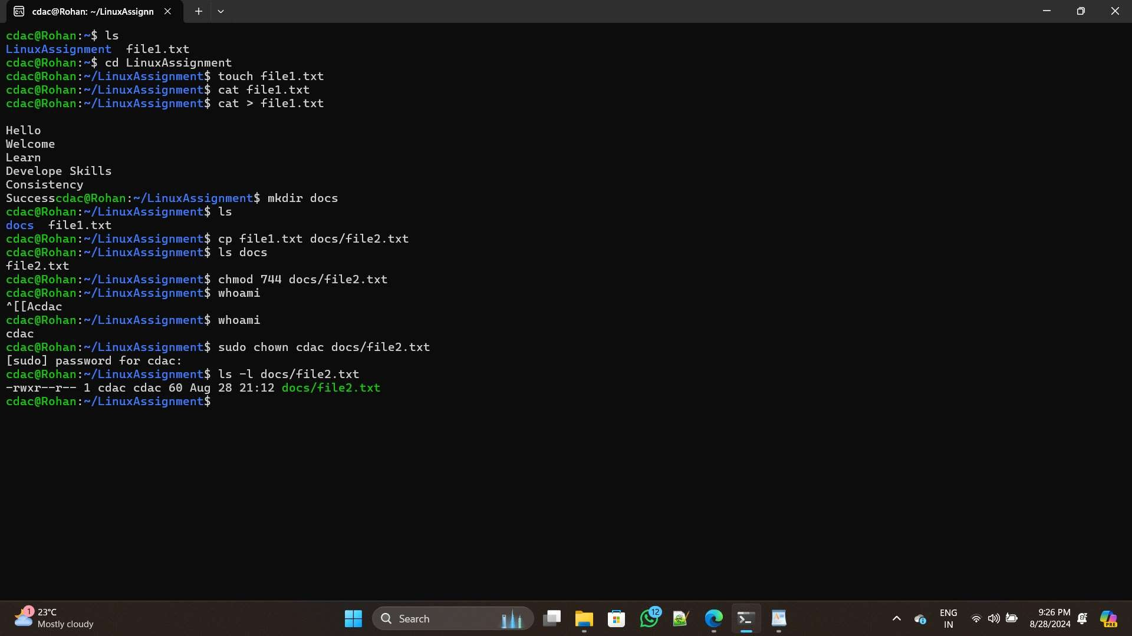

1. Final Checklist:

a. Finally, list the contents of the "LinuxAssignment" directory and the root directory to

ensure that all operations were performed correctly.

-->>

To List the contents of the " LinuxAssignment " directory :- ls -l

And to see the contents of the root directory :-

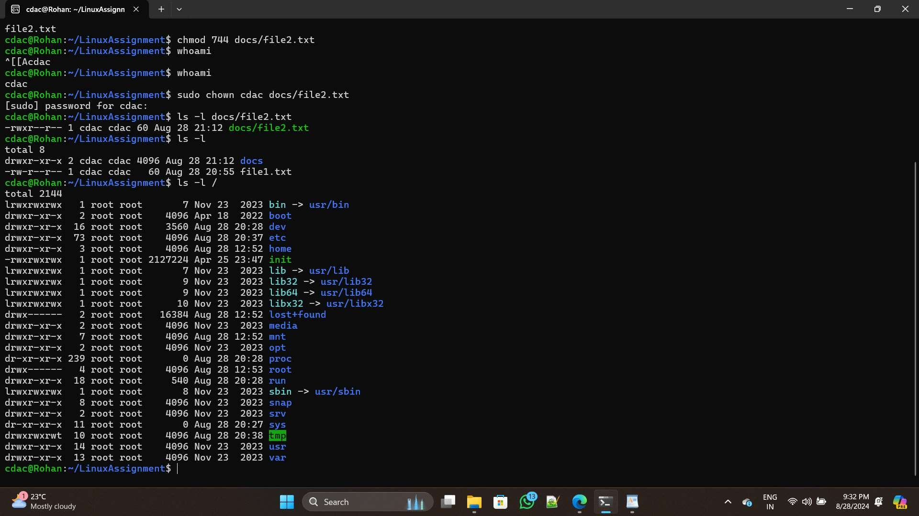ls -l /

1. File Searching:
2. Search for all files with the extension ".txt" in the current directory and its subdirectories.
3. Display lines containing a specific word in a file (provide a file name and the specific

word to search).

-->>

a.) -> Search for All Files with the Extension .txt :-

find . -type f -name "*.txt"

b.) Display lines containing a specific word in a file :-

If we want to search for the word "error" in a file named file1.txt, use:

grep "Hello" file1.txt

in the file.)

__ __ (" " here there must be the contents(keyword)

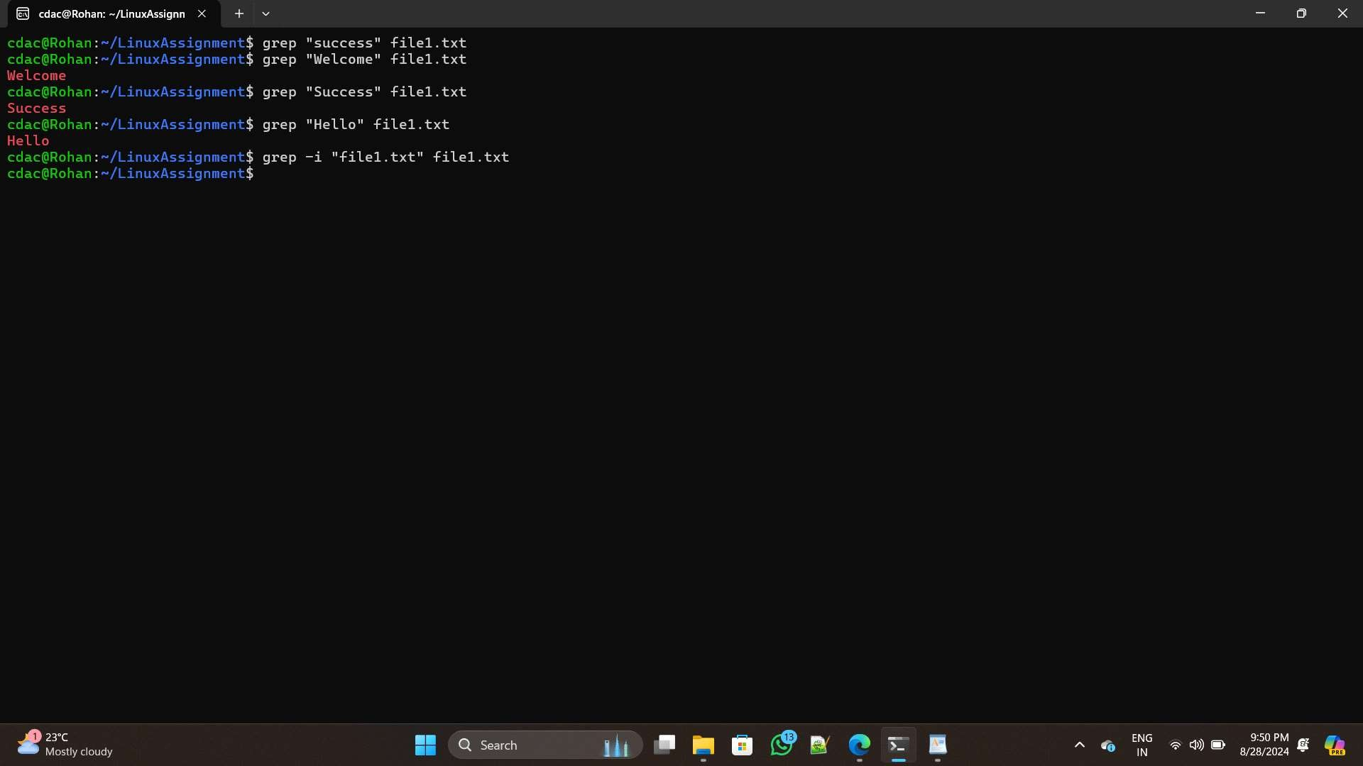

1. System Information:

a. Display the current system date and time.

-->>

Here, to display the current system date & time use the command :-

date

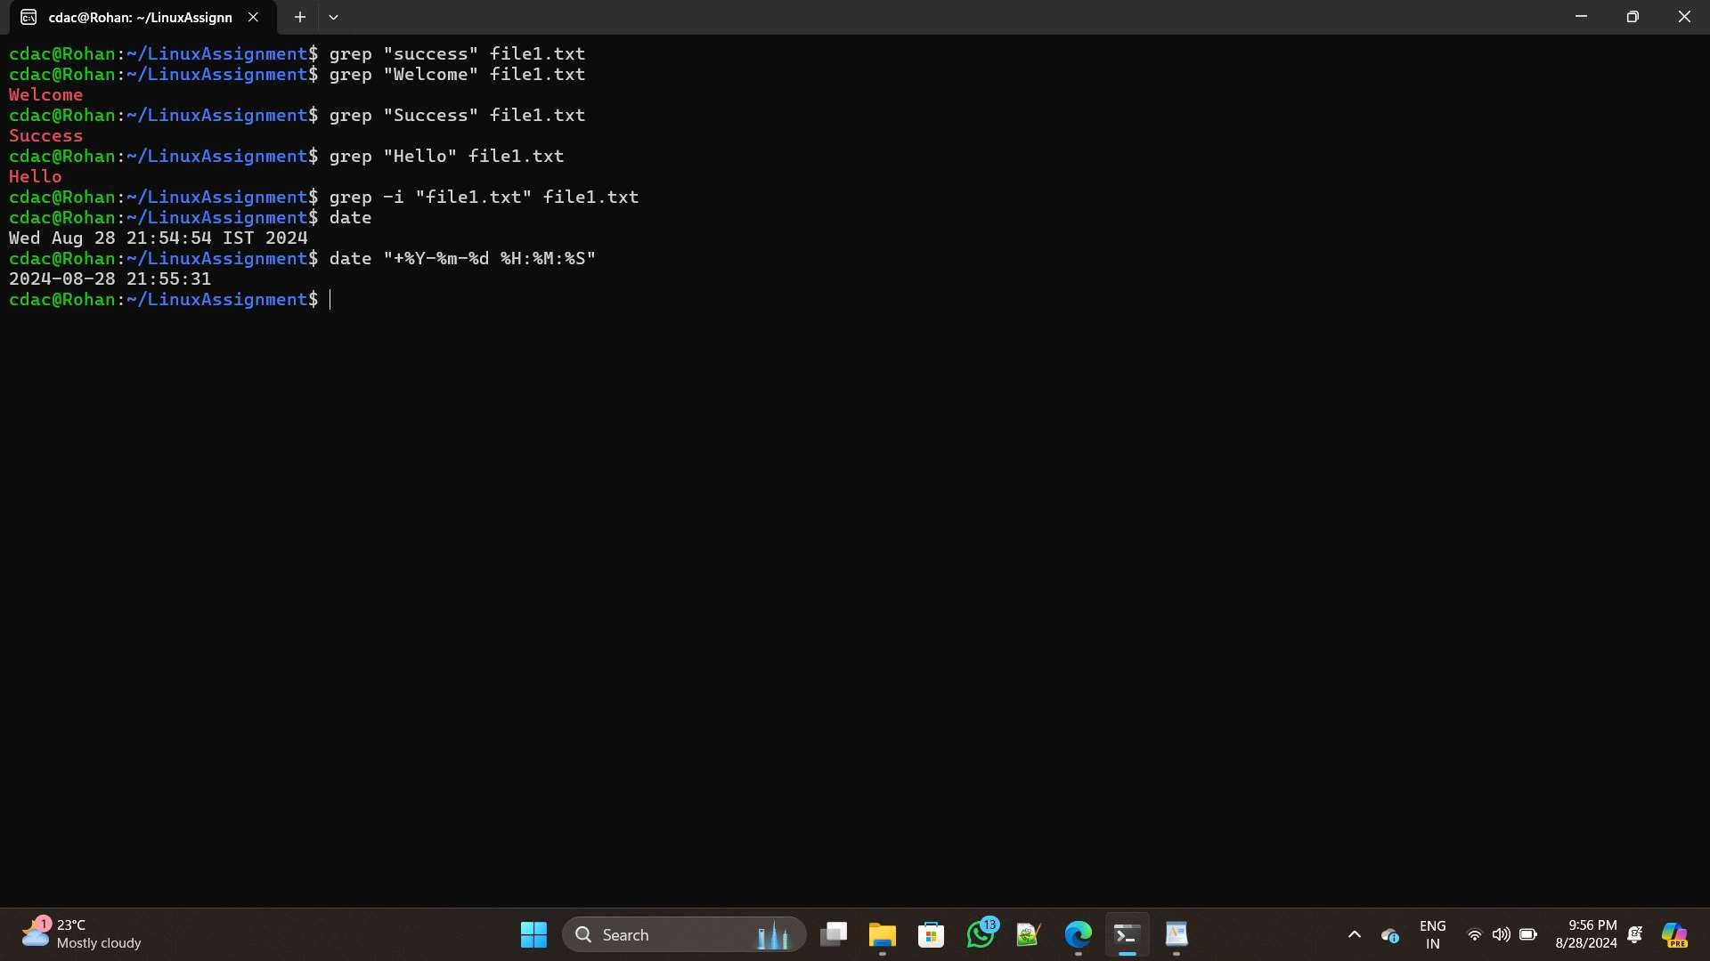

1. Networking:
2. Display the IP address of the system.
3. Ping a remote server to check connectivity (provide a remote server address to ping).

-->>

a.) -> To display the IP address of your system: ip addr show

To find just the IP address of the primary network interface more directly :-

hostname -I

To Ping Google's public DNS server:

ping 8.8.8.8

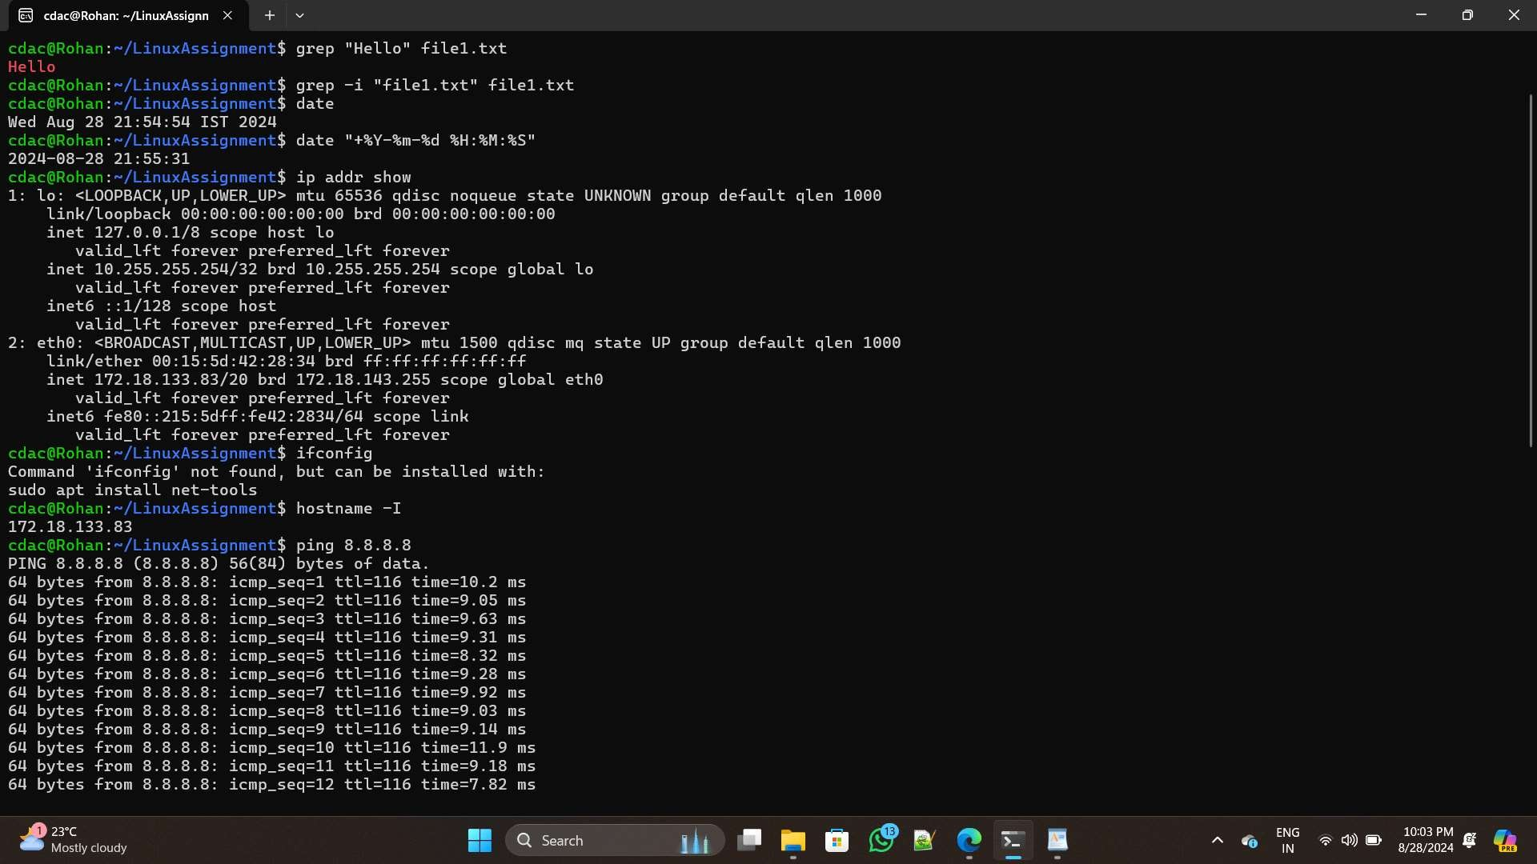

1. File Compression:
2. Compress the "docs" directory into a zip file.
3. Extract the contents of the zip file into a new directory.

-->>

a.) -> To compress the "docs" directory into a zip file:

zip -r docs.zip docs

b.) -> To create a new directory for extraction : mkdir extracted_docs

Now, extract the contents of the zip file into the new directory by : unzip docs.zip -d extracted_docs

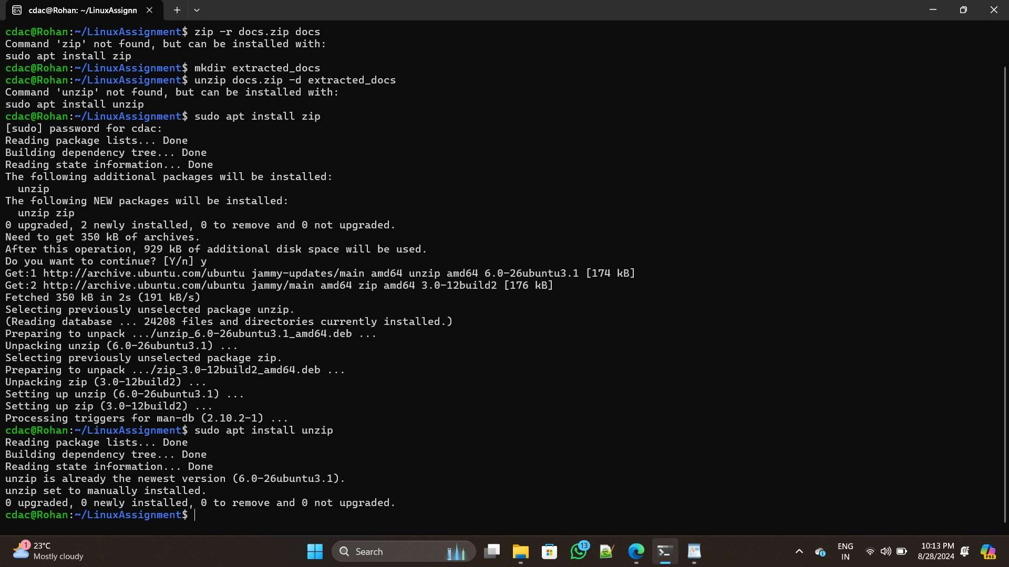

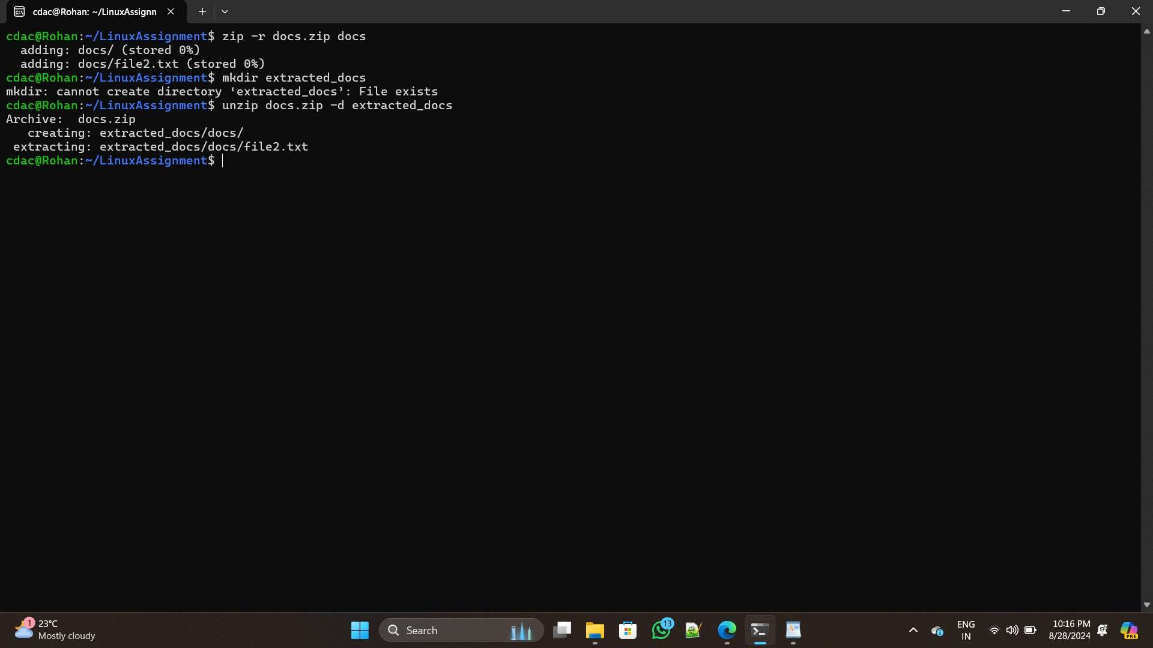

1. File Editing:
2. Open the "file1.txt" file in a text editor and add some text to it.
3. Replace a specific word in the "file1.txt" file with another word (provide the original

word and the word to replace it with).

-->>

a.) -> 1.)_ Open the file in nano: nano file1.txt

By using vim:

Open the file in vim:

vim file1.txt

(Use i to insert new content and then esc and :wq & press enter to save and exit).

b.) -> To replace a specific word with another word, we can use the sed command like :-

sed -i 's/GGWP/GGS/g' file1.txt

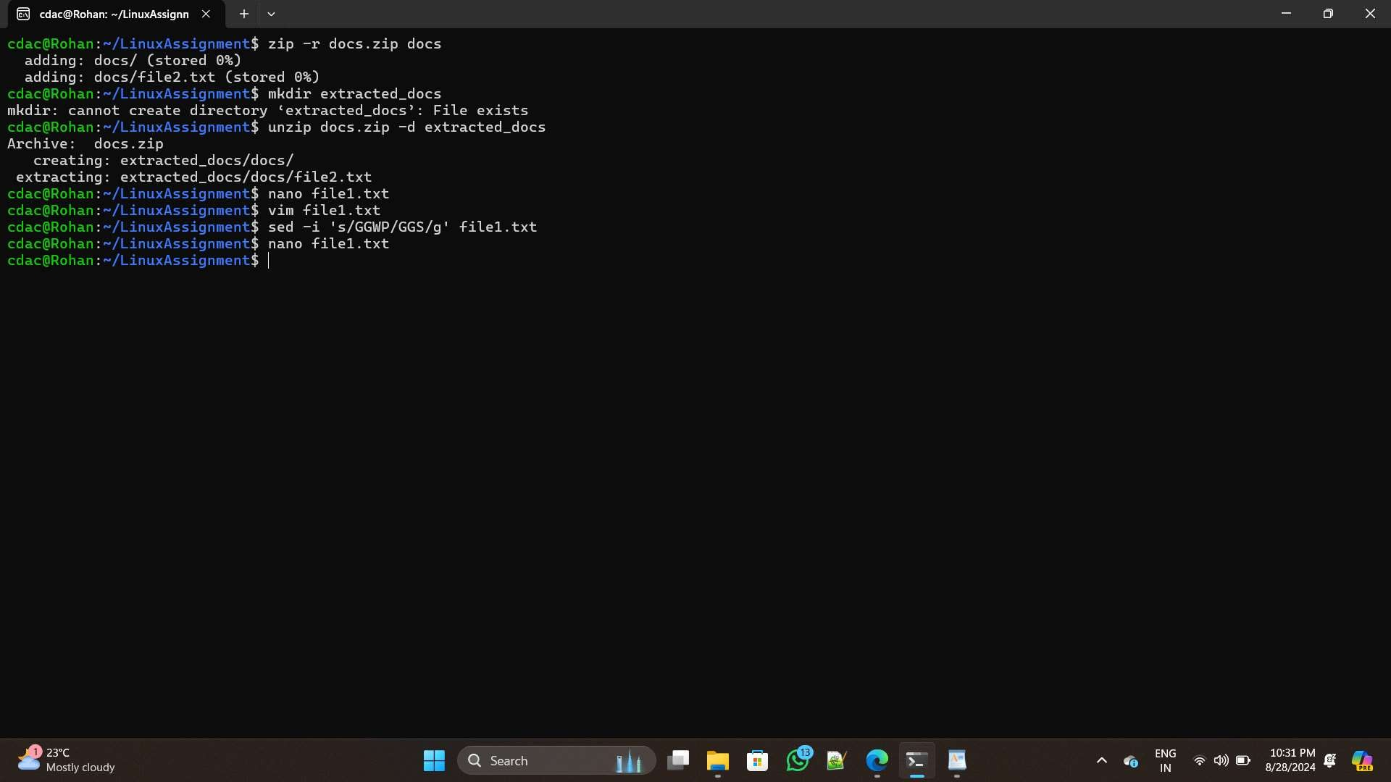

Problem 2: Read the instructions carefully and answer accordingly. If there is

any need to insert some data then do that as well.

a.) Suppose you have a file named "data.txt" containing important information. Display the first 10 lines of this file to quickly glance at its contents using a command.

-->>

head -n 10 file1.txt

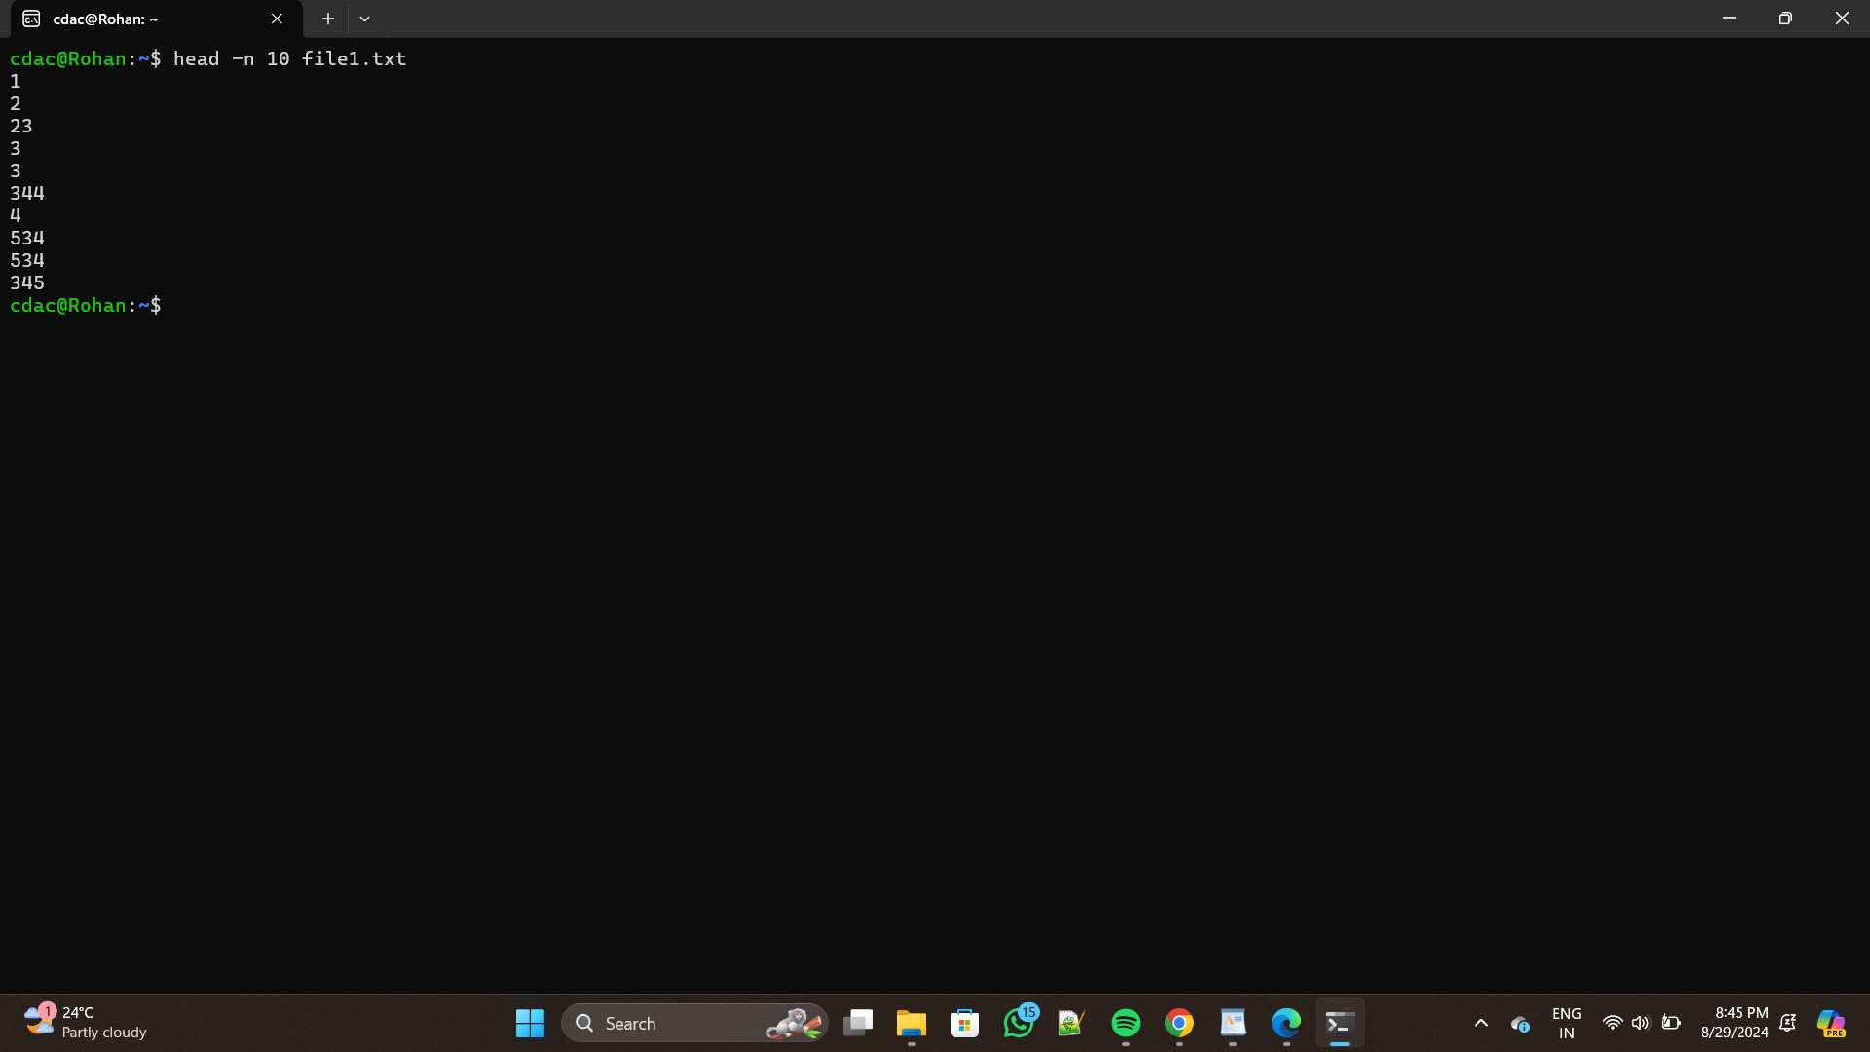

b. Now, to check the end of the file for any recent additions, display the last 5

lines of "data.txt" using another command.

-->>

tail -n 5 file1.txt

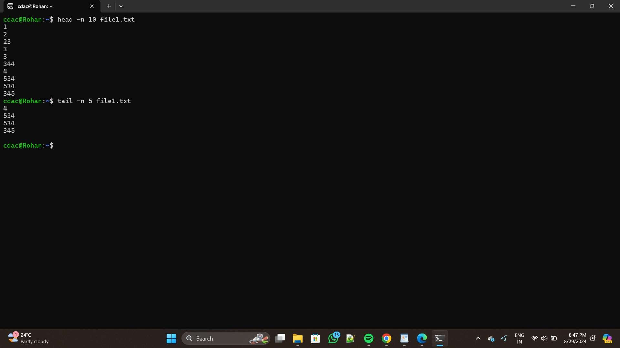

c.) In a file named "numbers.txt," there are a series of numbers. Display the

first 15 lines of this file to analyze the initial data set.

-->>

head -n 15 numbers.txt

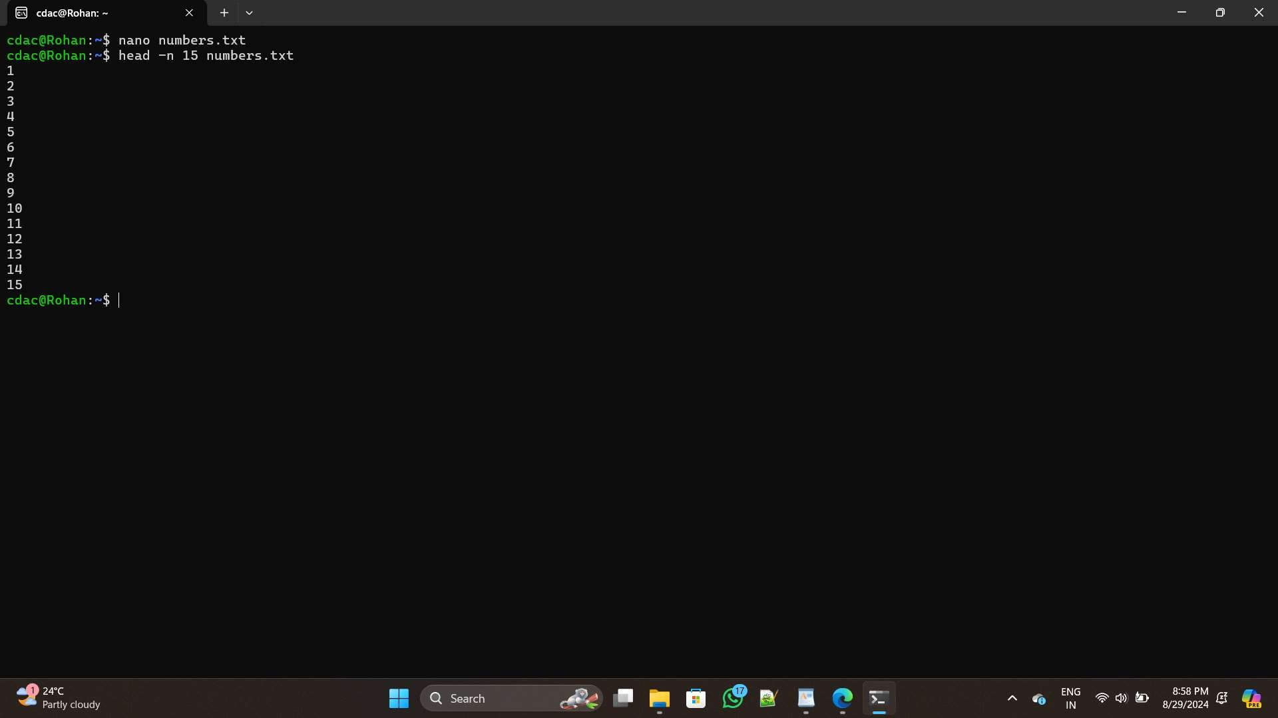

d.) . To focus on the last few numbers of the dataset, display the last 3 lines of

"numbers.txt".

-->>

tail -n 3 numbers.txt

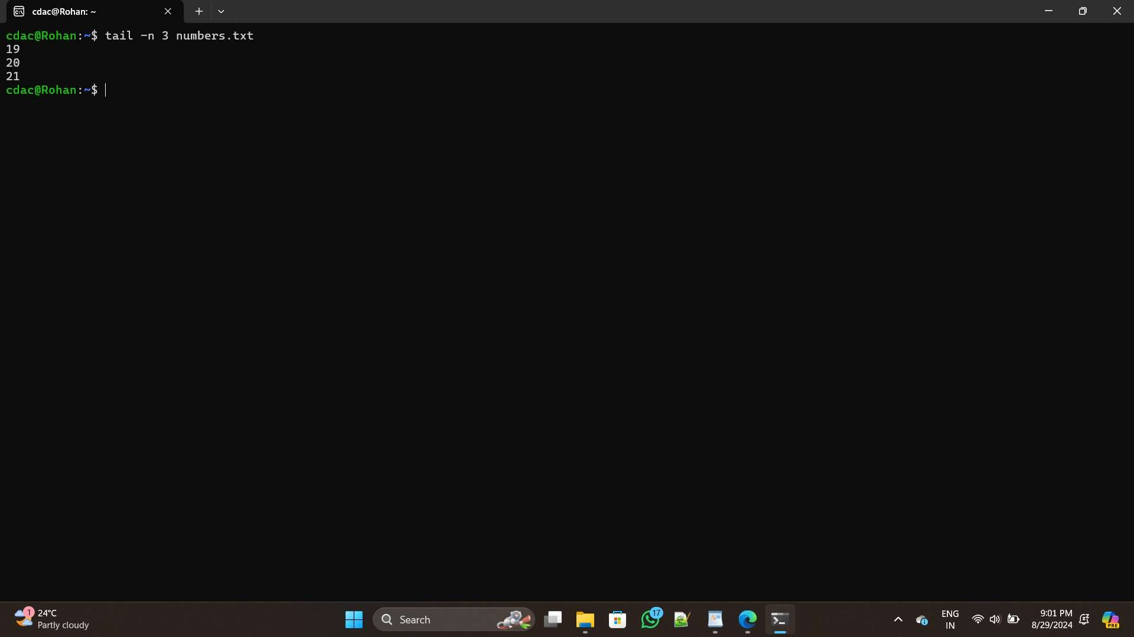

e.) Imagine you have a file named "input.txt" with text content. Use a

command to translate all lowercase letters to uppercase in "input.txt" and save the modified text in a new file named "output.txt."

-->>

tr '[:lower:]' '[:upper:]' < input.txt > output.txt

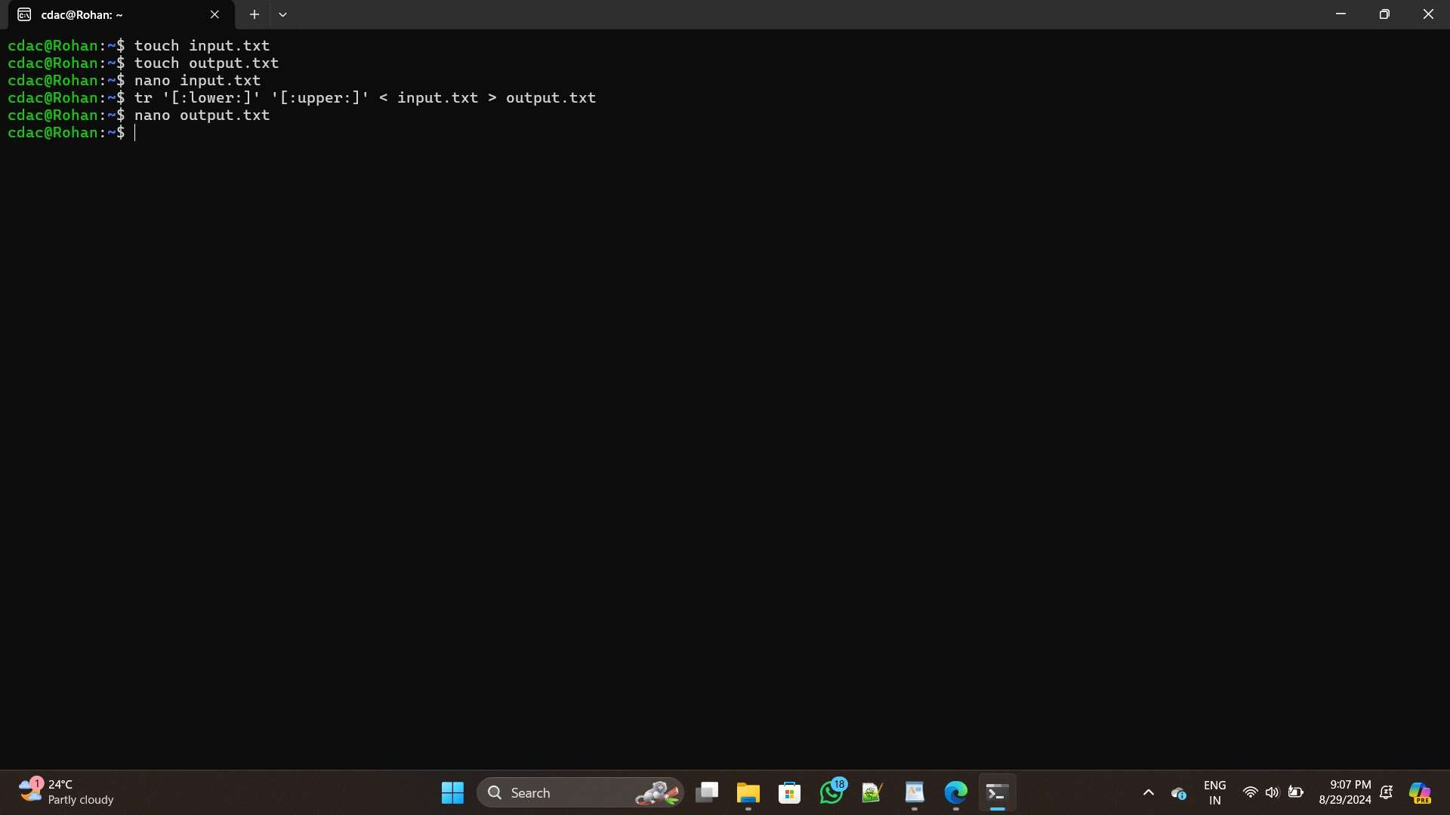

f.) In a file named "duplicate.txt," there are several lines of text, some of which

are duplicates. Use a command to display only the unique lines from "duplicate.txt."

-->>

sort duplicate.txt | uniq uniq duplicate.txt

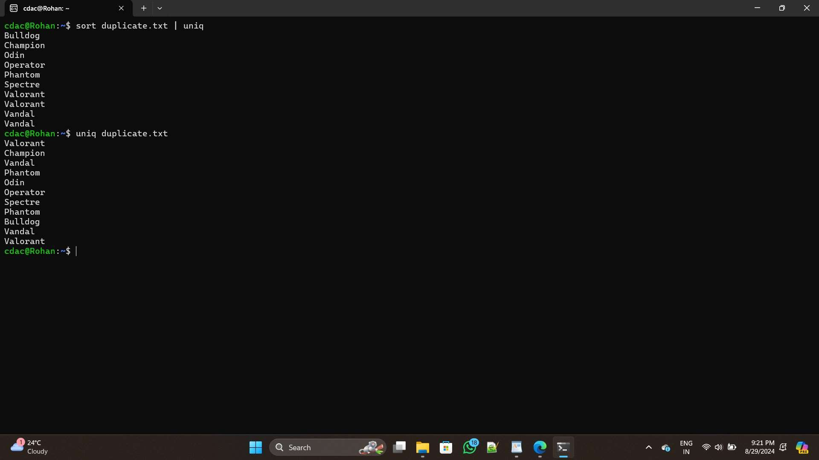

g.) In a file named "fruit.txt," there is a list of fruits, but some fruits are

repeated. Use a command to display each unique fruit along with the count of its occurrences in "fruit.txt."

-->>

sort fruit.txt | uniq -c

